**MIDDLETON CHENEY FOOTBALL CLUB**

**ANNUAL GENERAL MEETING**

**1986**

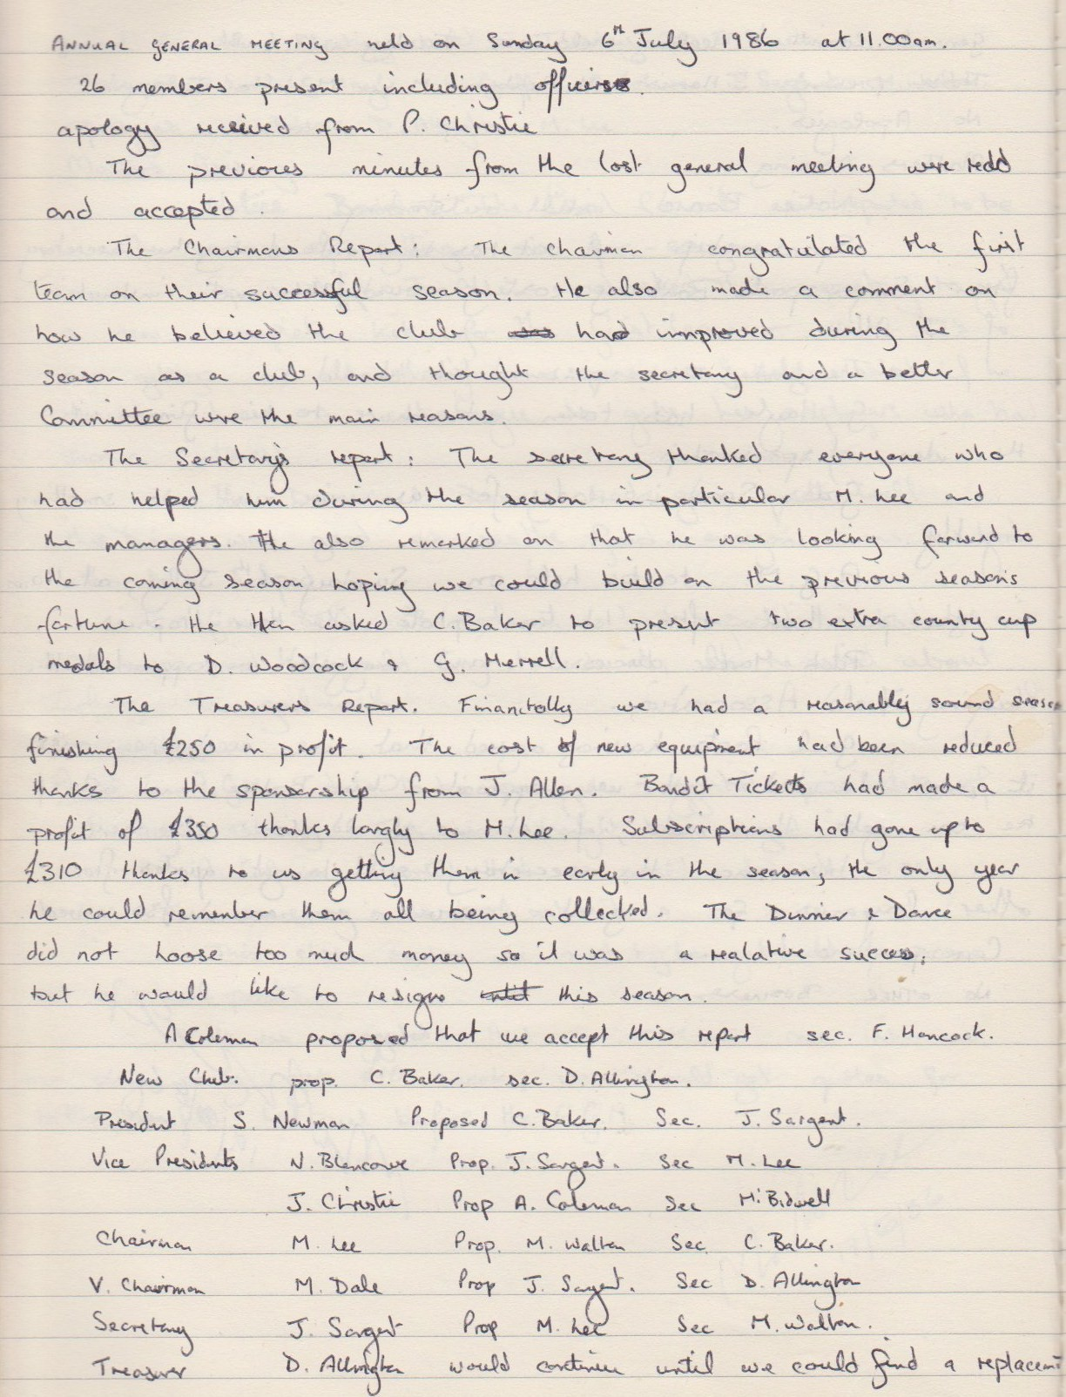

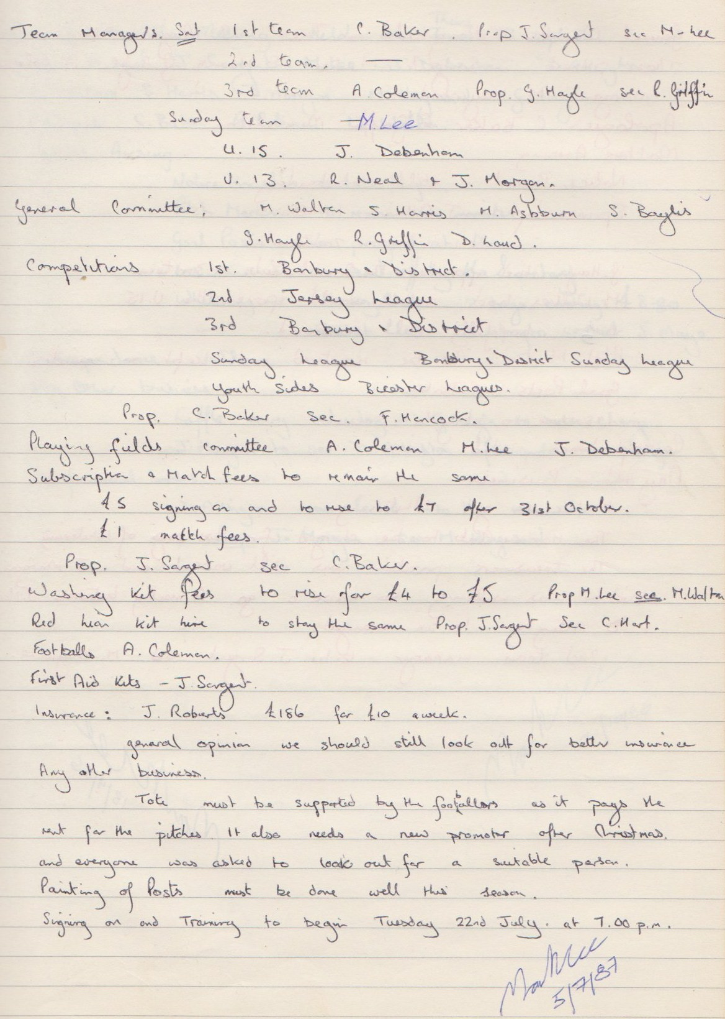

**General Committee Meeting**

**August 19th 1986**

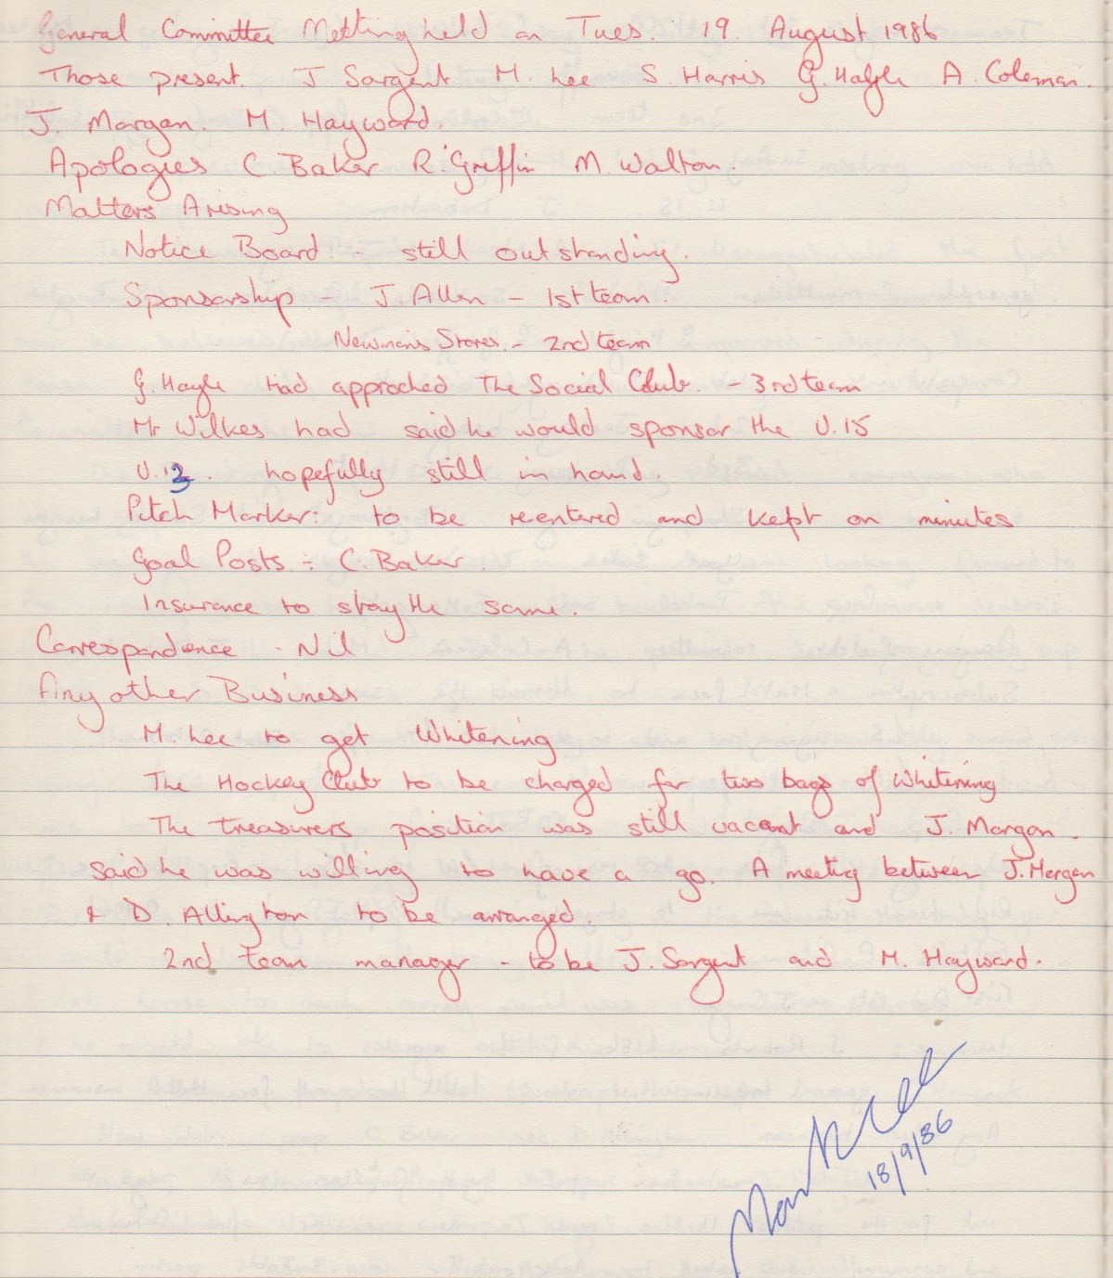

**General Committee Meeting**

**September 18th 1986**

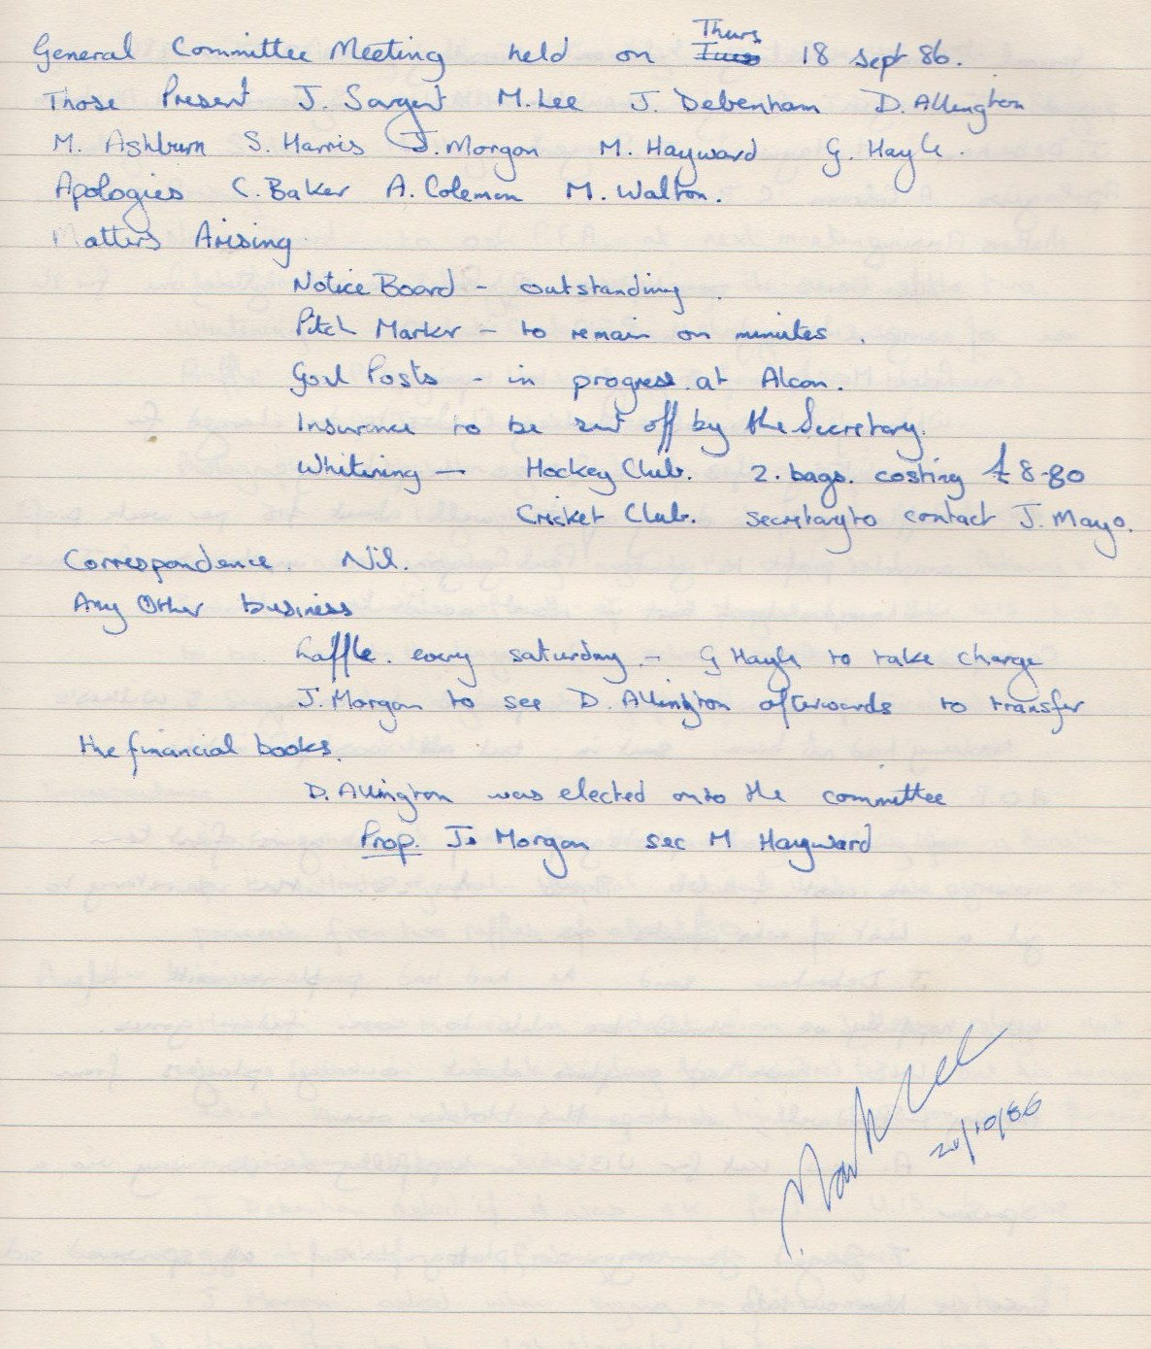

**General Committee Meeting**

**October 21st 1986**

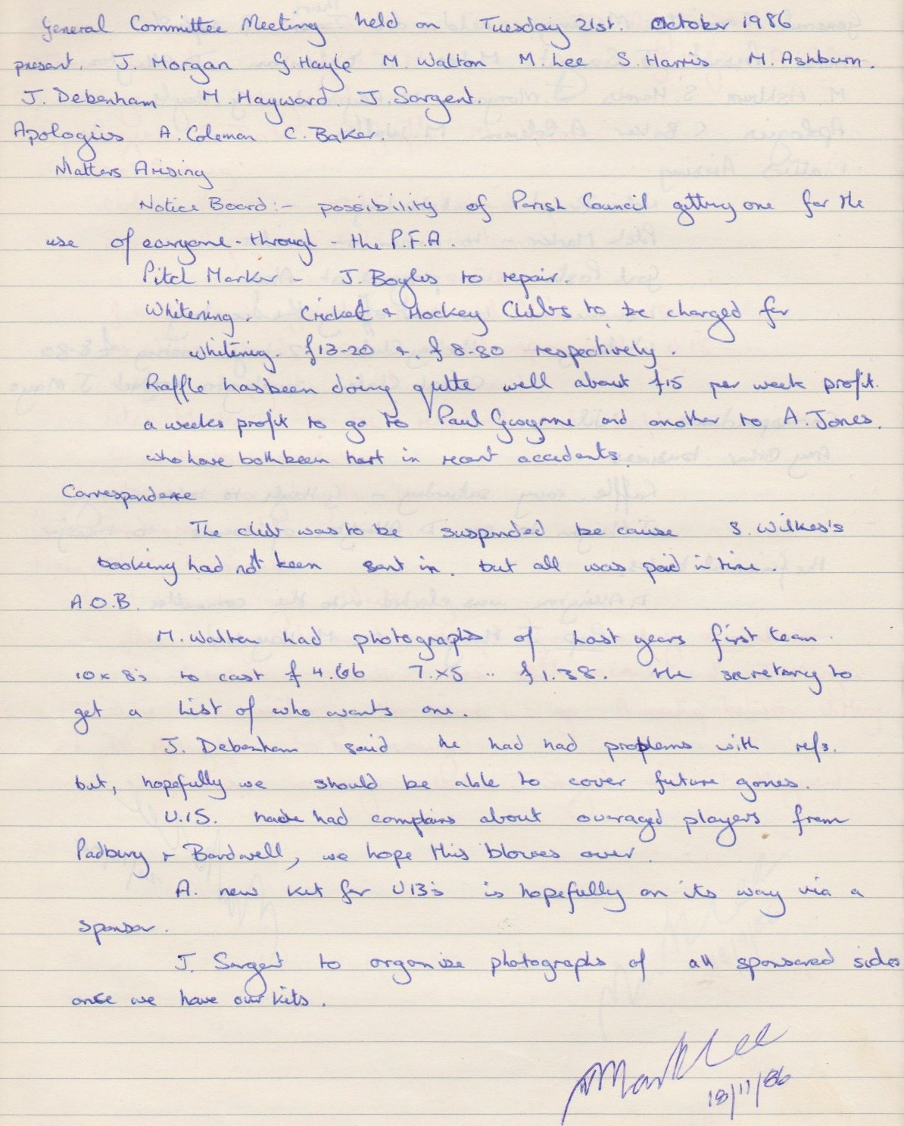

**General Committee Meeting**

**November 18th 1986**

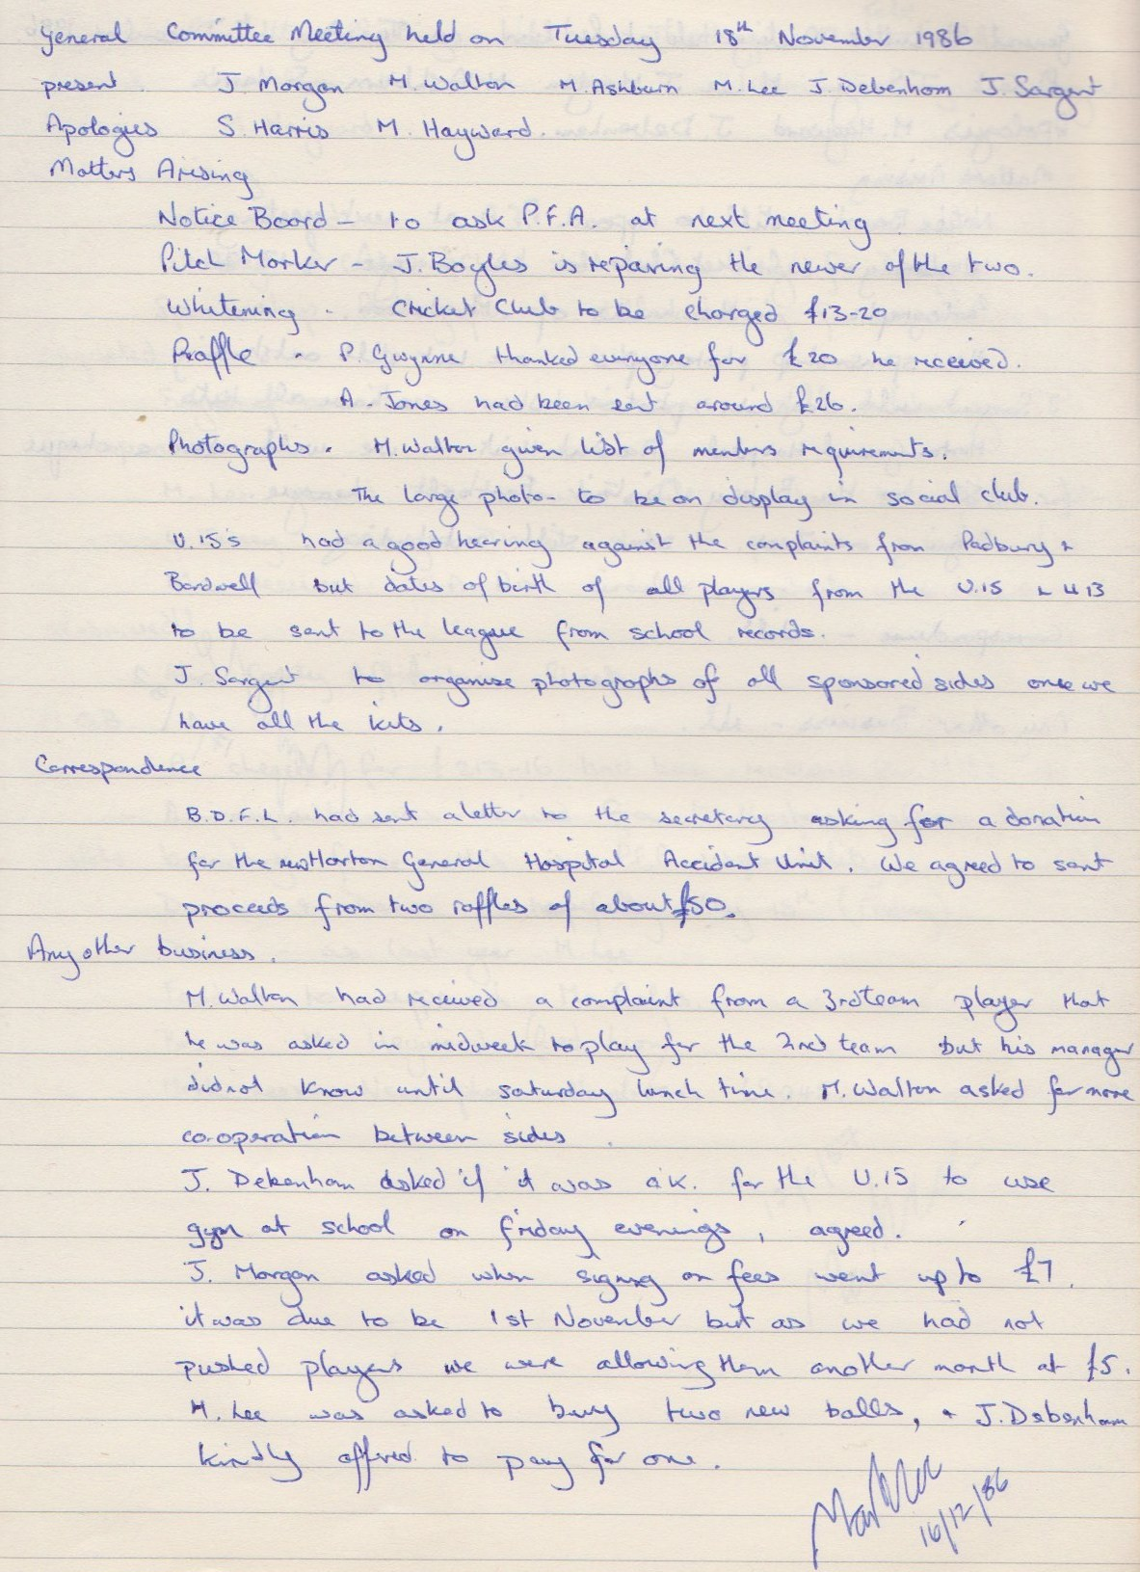

**General committee Meeting**

**December 16th 1986**

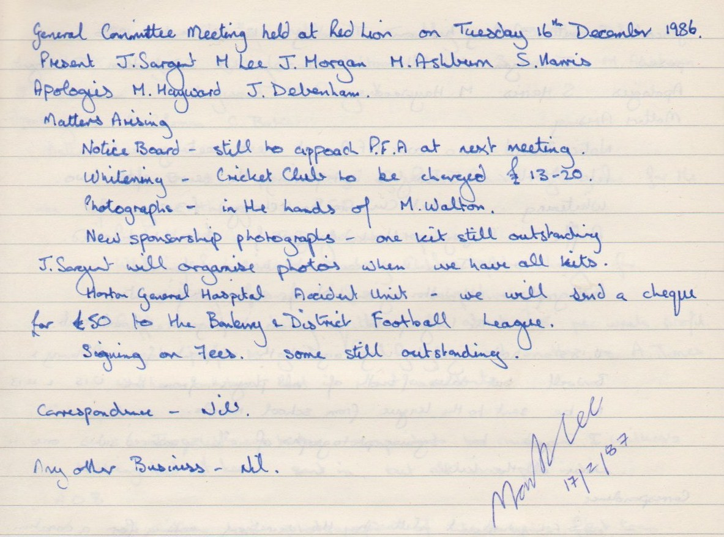

**General Committee Meeting**

**February 17th 1987**

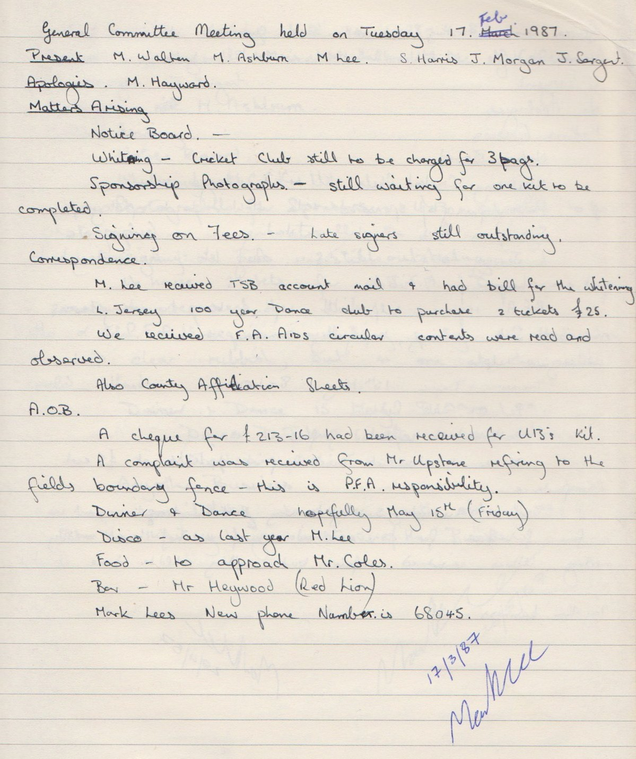

**General Committee Meeting**

**March 17th 1987**

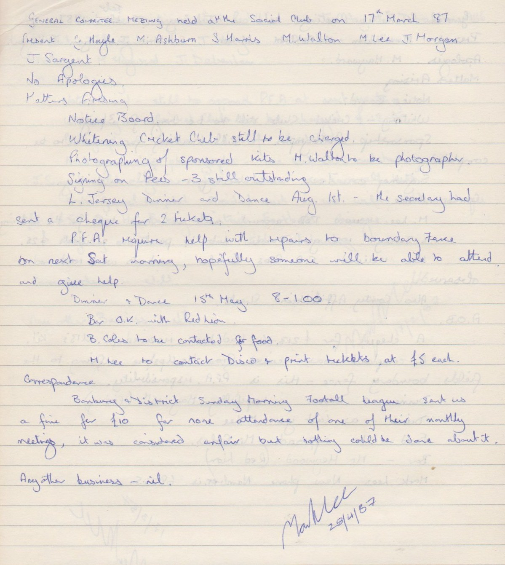

**General Committee Meeting**

**April 28th 1987**

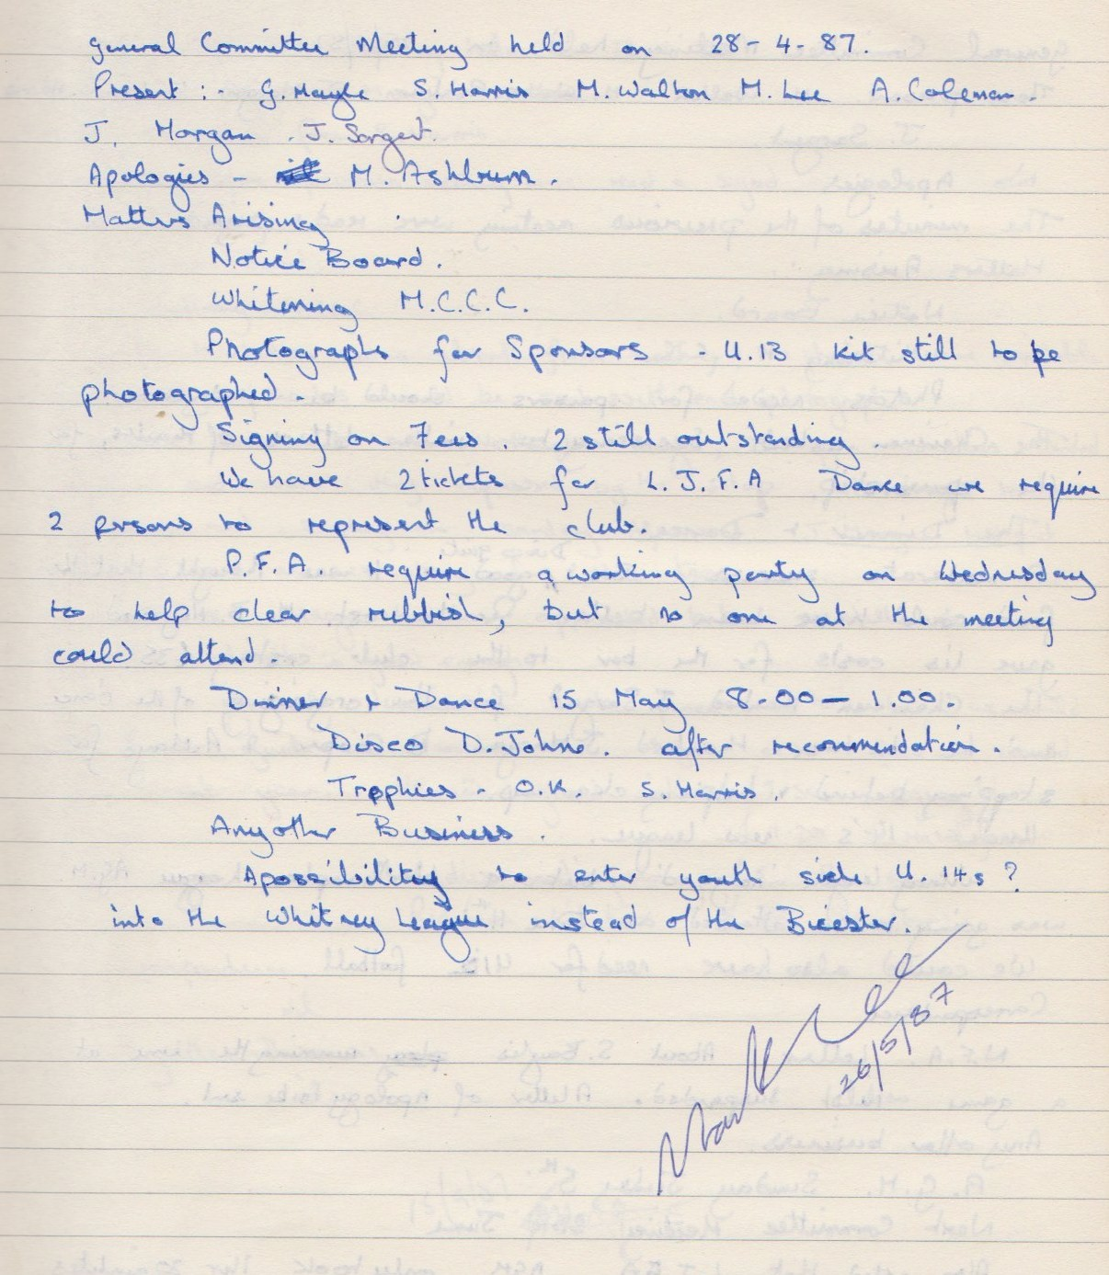

**General Committee Meeting**

**May 25th 1987**

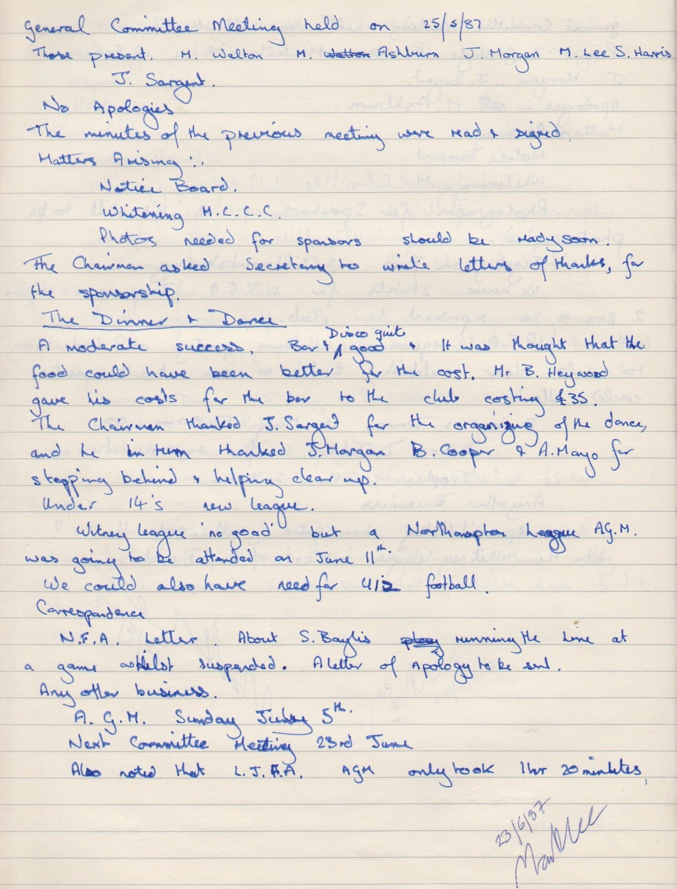

**General Committee Meeting**

**June 23rd 1987**

